

**American International University- Bangladesh**

**CSC 3215: Web Technologies**

**CO1 and CO3 Evaluation**

**Project Report**

**Summer 2019-2020**

**Project Title: Online Hospital Management System**

**Section: F**

|  |  |
| --- | --- |
| Student Name | Student Id |
|  |  |
|  |  |
|  |  |
|  |  |

**Introduction:**

We are doing an online hospital management system project. This will help both Hospital management and Patient also. We have created many features for Hospital management, Doctors and Patients also. Doctors can create a profile for him. That profile he/she can manage his profile, patient's history and so on. Patient can also create a profile for himself and also can book an appointment with doctors, can send messages to doctors, can save his/her medical history and so on. Our software is going to be very user friendly.

**Background Study**

Well, we have studied some papers and also viewed some hospital management system related websites.

From this paper (“Reference: <https://m.mu.edu.sa/sites/default/files/content/2018/11/MAJD.pdf>”) we got some idea for our project. This paper is published by some student from Department of Computer Science & Information Majmaah University College of Science at Az-Zulfi Kingdom of Saudi Arabia. Another paper is

(Links- <http://www.mecs-press.org/ijieeb/ijieeb-v5-n1/IJIEEB-V5-N1-6.pdf> ) . Later we also view some Bangladeshi hospitals website. Like Apollo hospitals, united hospital Ltd. (Links- <https://www.uhlbd.com/>). We also viewed some websites where they already make a management hospitals. (Links- <https://www.kashipara.com/project/html-css-template/949/hospital-management>).

**Requirement Analysis:**

1. **User Category:**

There are four types of Users here. They are:

* Admin
* Doctor
* Patient
* Blood Bank

1. **Feature List:**

In this project the “User Type Admin” has the following features:

* Can register to the system
* Can log in to the system
* Can register patient
* Can register doctors
* Can register staffs
* Can view the details of the users
* Can see appointment history
* Can assign nurse to a doctor
* Can show job availability
* Can also canhge his own password
* Can(update-view-delete) his profile
* Can receive complains from other users

In this project the “User Type Doctor” has the following features:

* Can provide Emergency Health Service
* Medical tour facilities
* Have Patient Details
* Doctors Information
* Affordable full body check ups
* Ask a health question
* Multiple Health Tips
* Chamber Details
* Testimonial for doctors
* Can Order Ambulance
* Emergency Sample Collection
* Nursing for home

In this project the “User Type Patient” has the following features:

* Log-in
* Sign up
* Can see Medical History
* Book Appointment facility
* Health News available
* Weight/Height Calculation
* See Doctors List
* Can make Routing
* Can see future Appointment Date
* Medicine List
* Can see test report

In this project the “User Type Blood Bank” has the following features:

* Sample collection
* Donate money
* Donate Blood
* Become a member
* Become a volunteer
* Central service for everyone
* Finance Division
* Information
* Managing Board availability
* Mission and Vission
* About the Movement
* Photo Gallery available

**Design:**

Draw an entity diagram of your project here.

**Tools Used:**

To develop this project, we have used the following:

• Bracket

• Xampp

• Atom

**System Images against the Specification:**

Give a screen shot of some GUIs (Midterm project) and write a very small description (Maximum 40 words) for each of the GUIs.

Here is the gui design for admin’s part

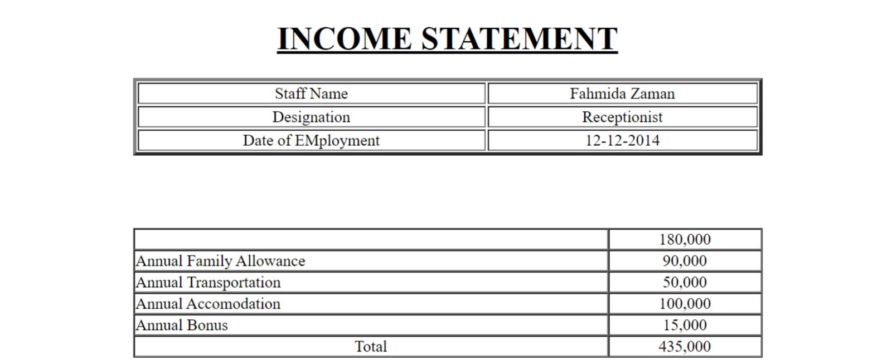

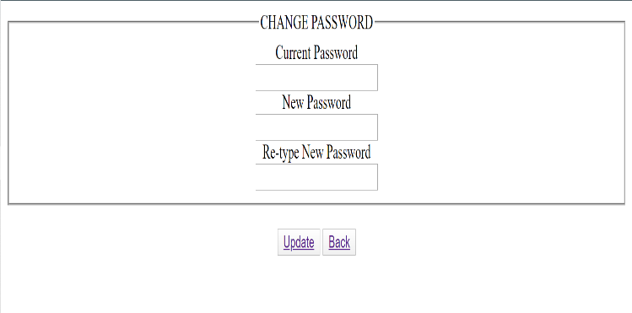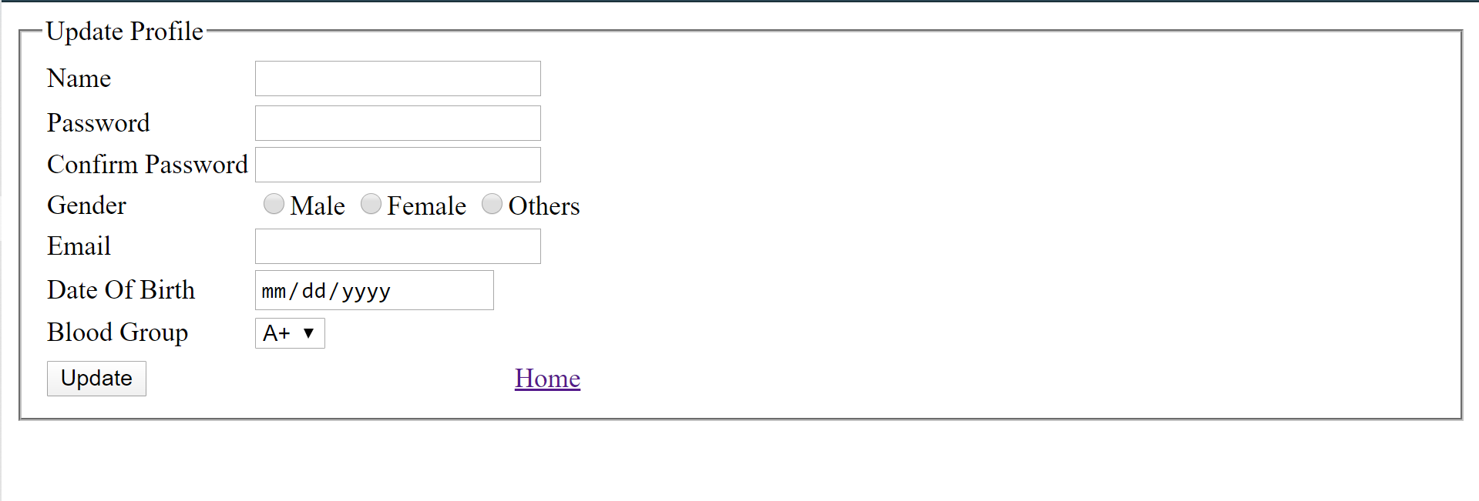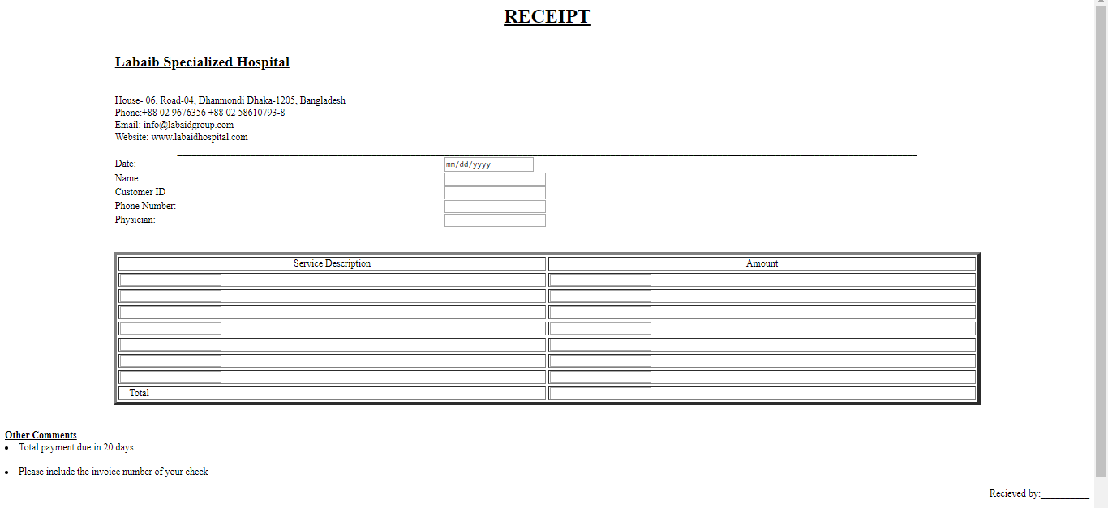

Here is the gui design for doctor’s part

Here are the multiple offers for full body health checkups.Patient can sign sign in and check up for details.

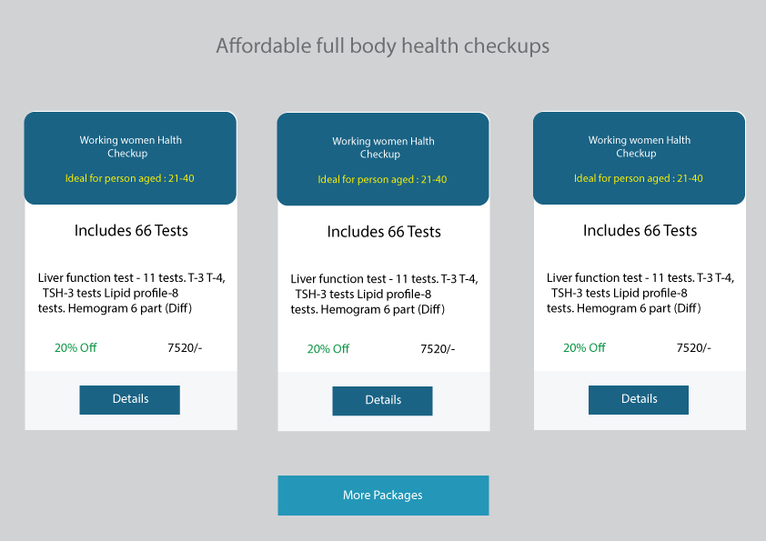

This is for to get instant appointment. If patients is in need of instant appointment.

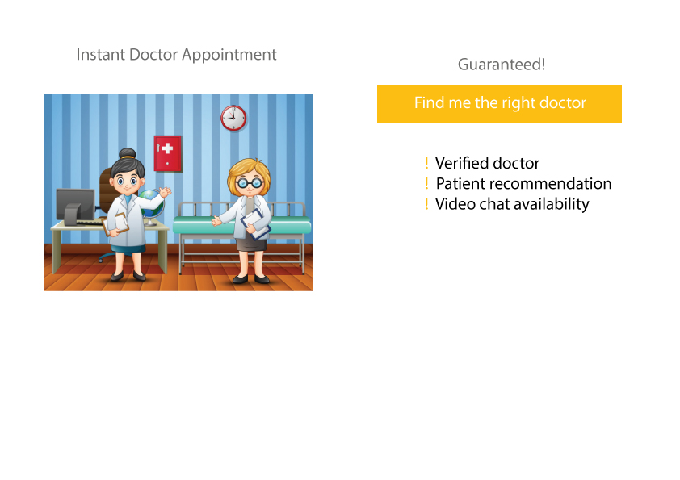

This is the design for emergency for health services.Like in case you need to order ambulance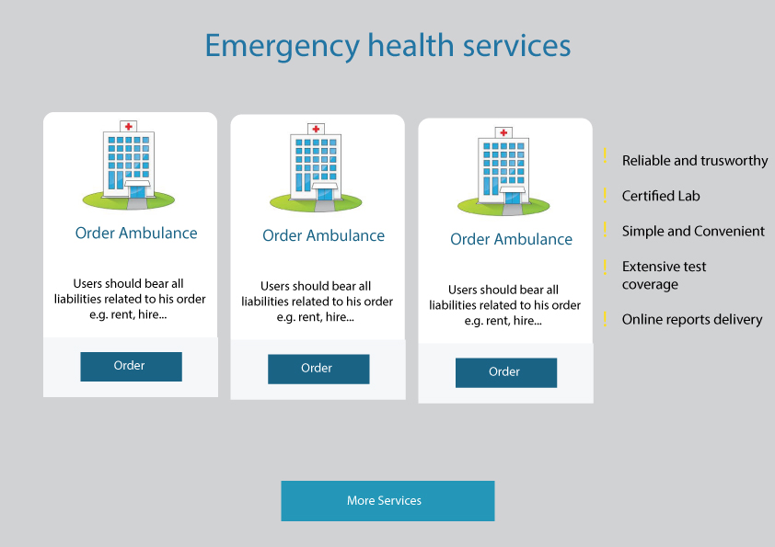

Here you can see the affliated hospitals where you can visit physically for to get better treatments.

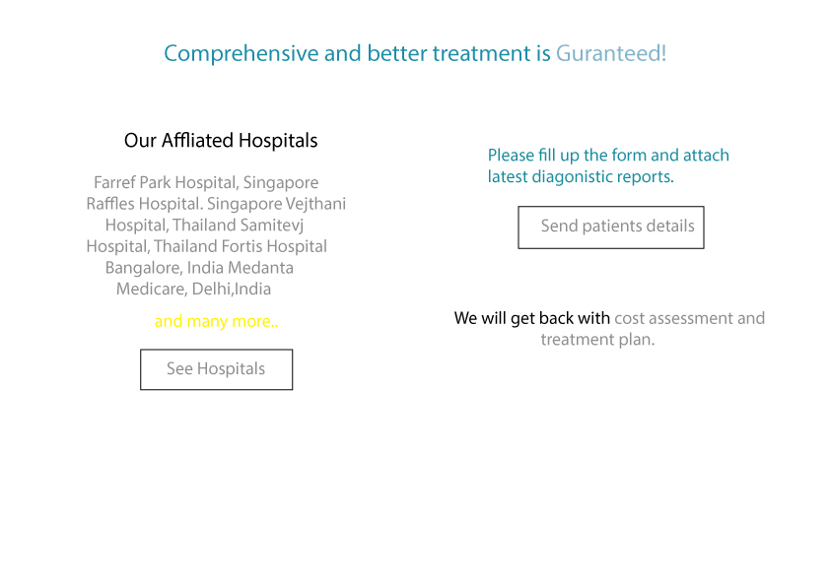

Here is the gui design for Patients part

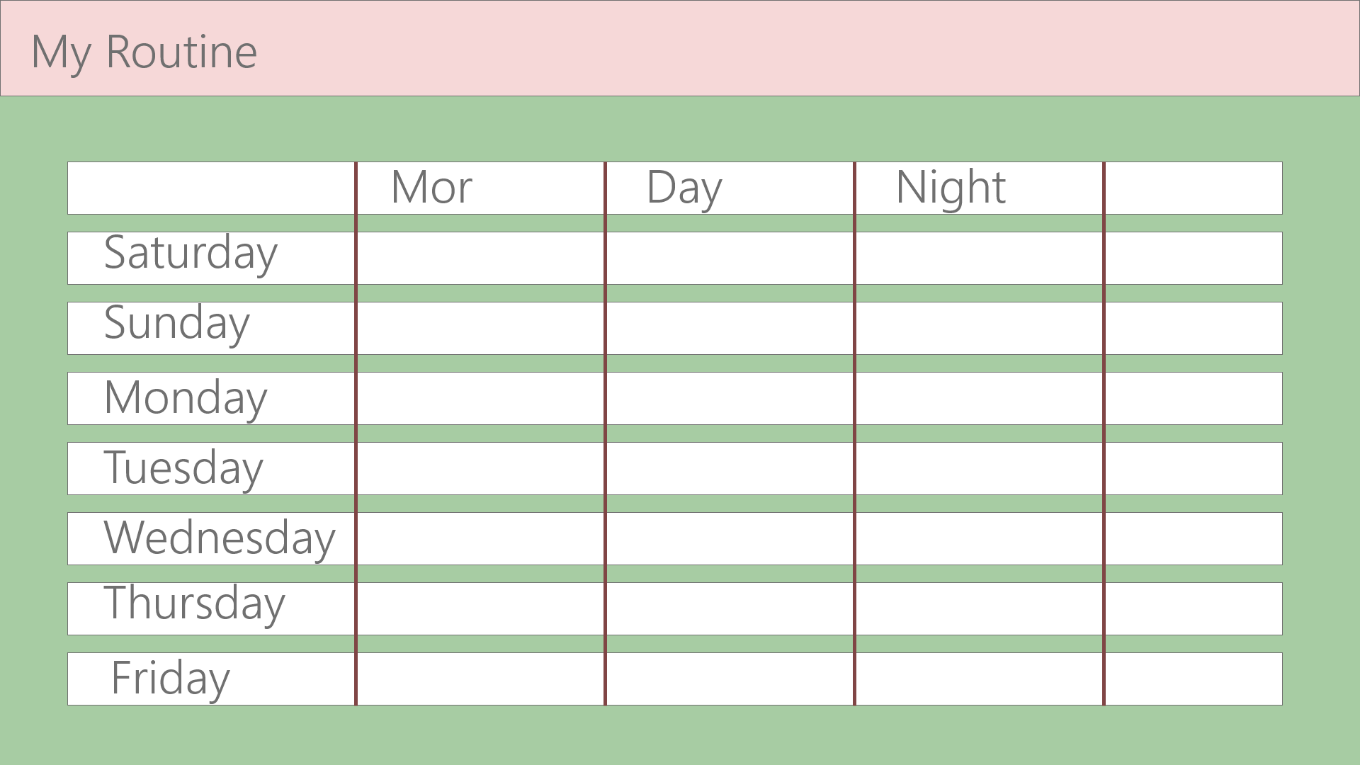

Here are details of doctor

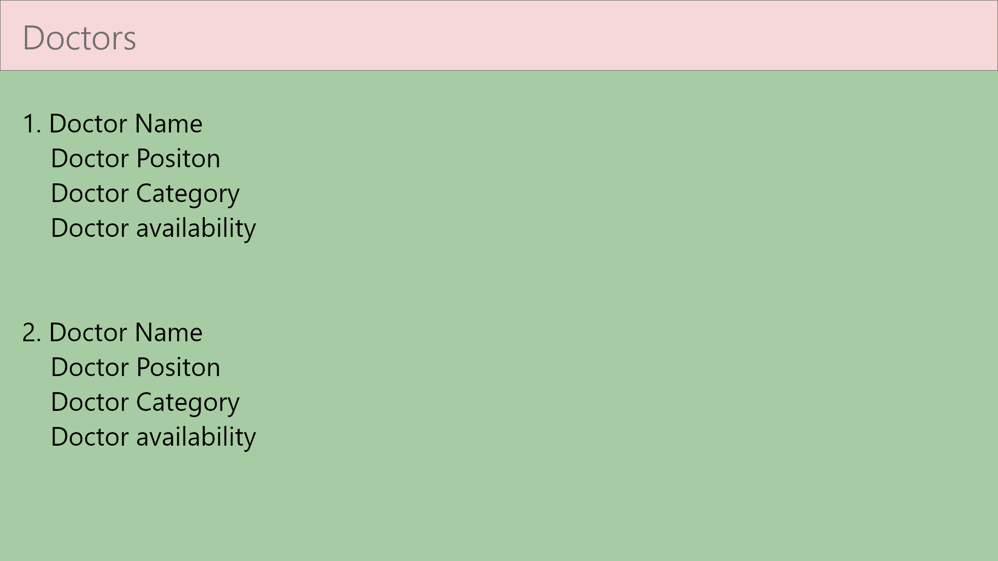

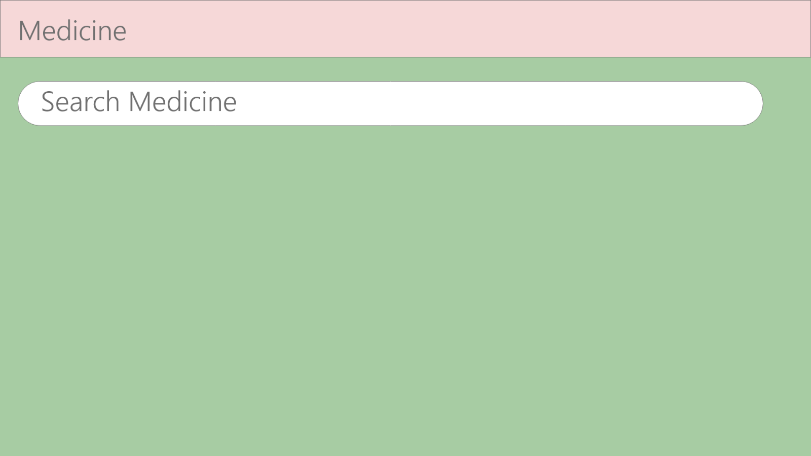

Here are the emergency needs

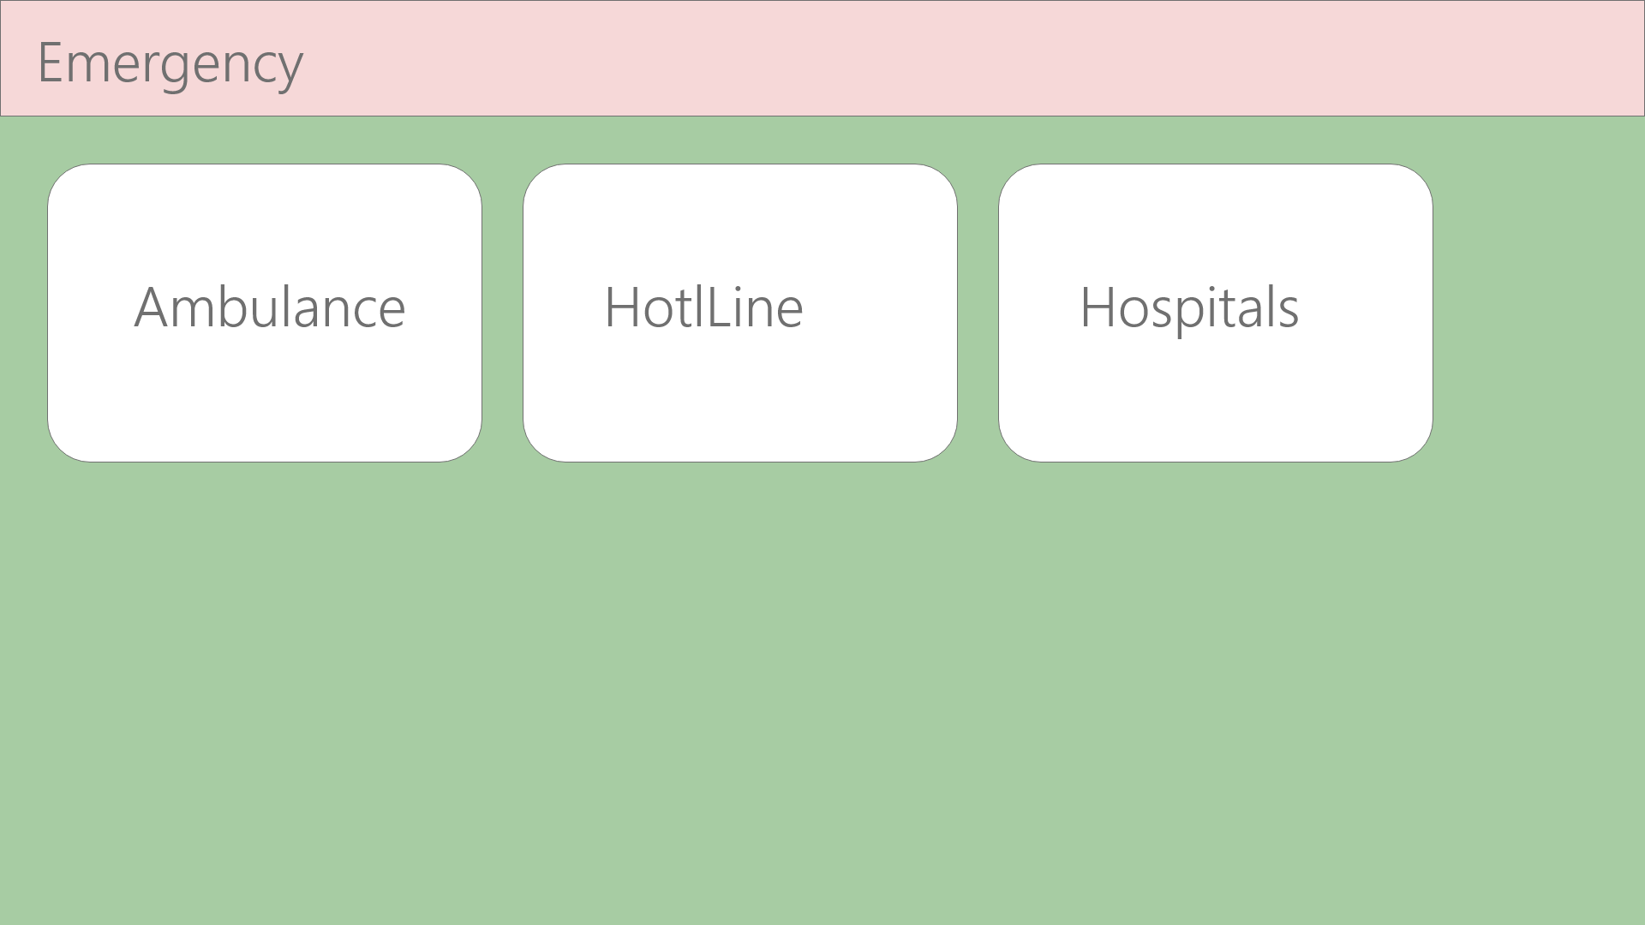

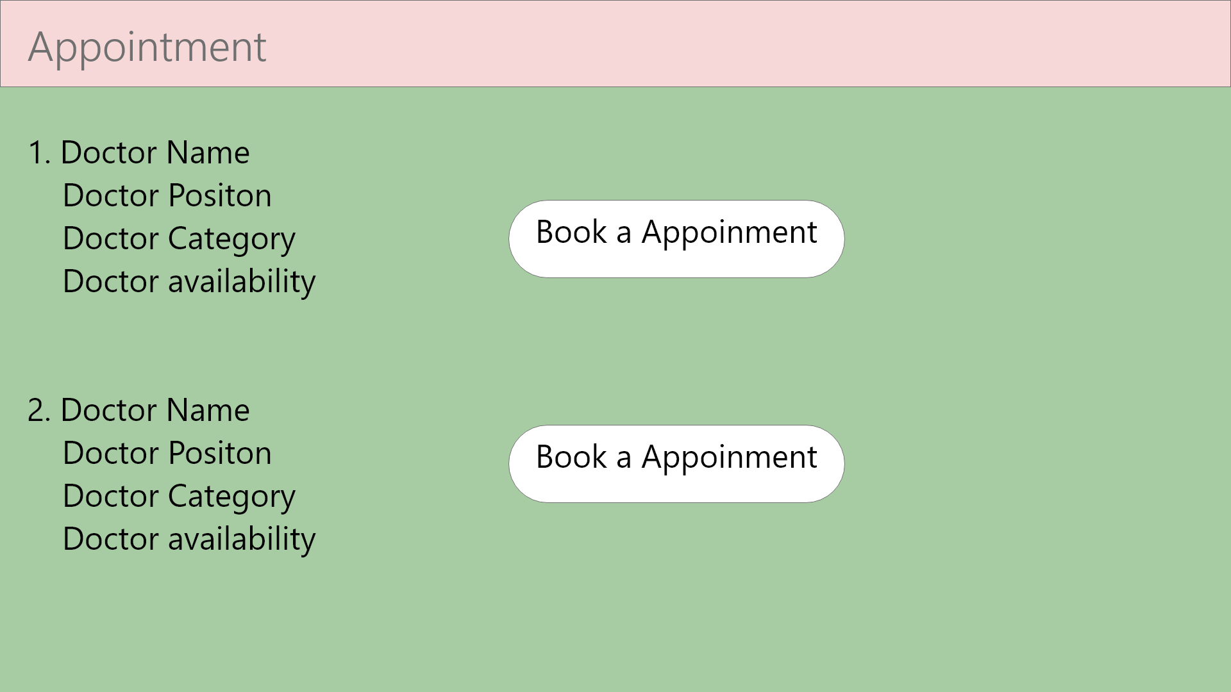

Here doctor can give health tips



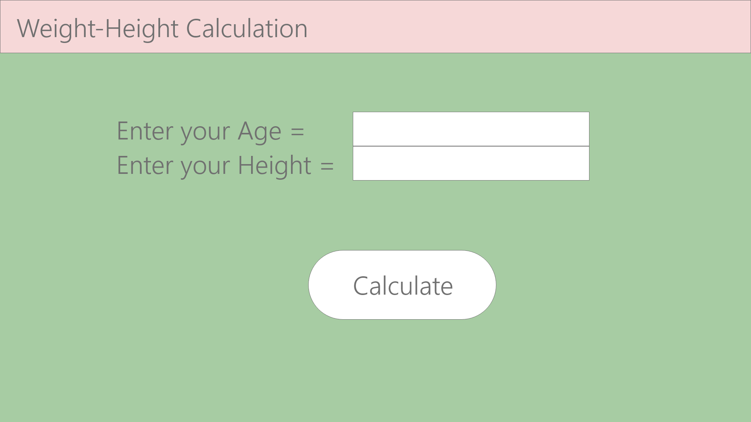

Here will be the patient information

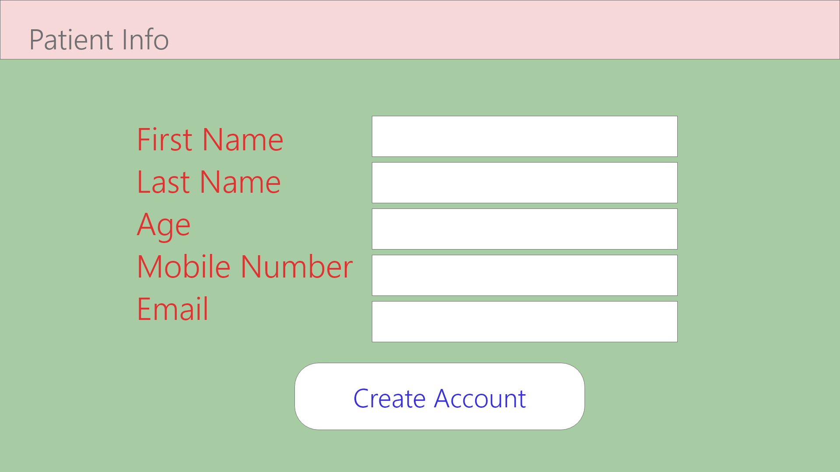

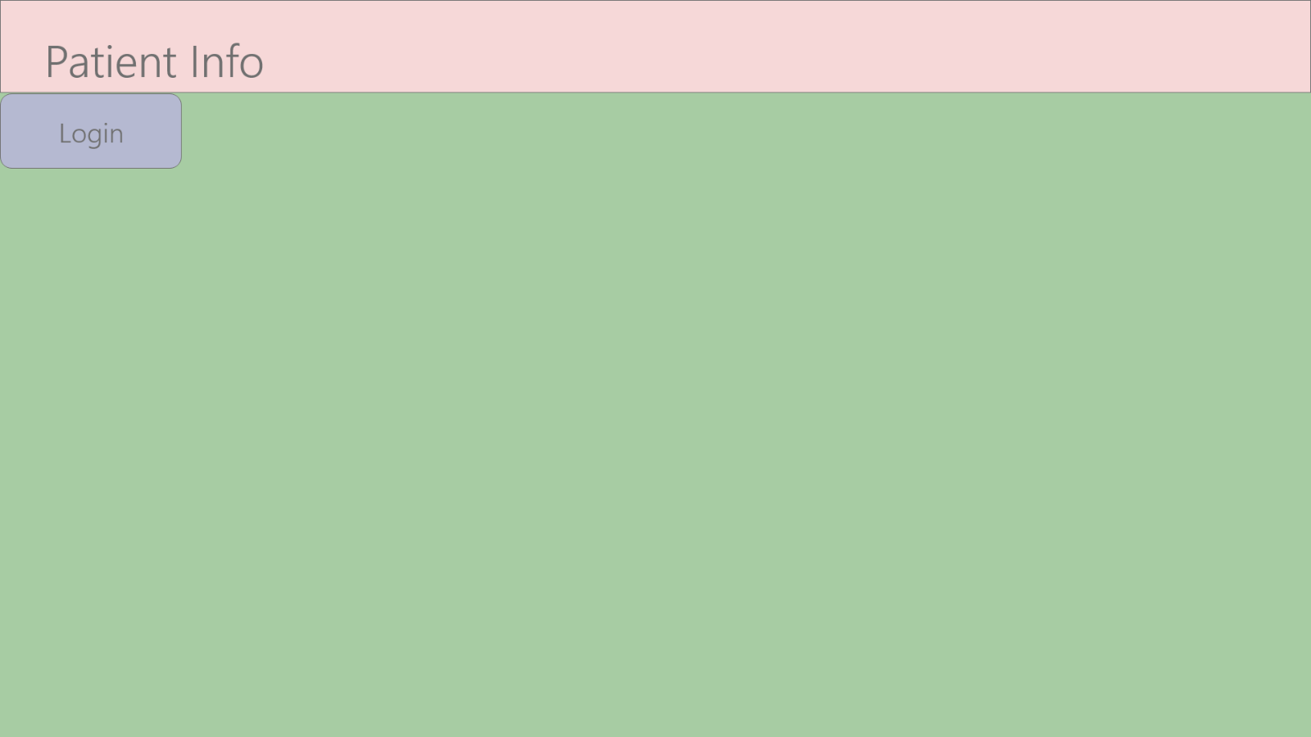

Here will be the prescription details

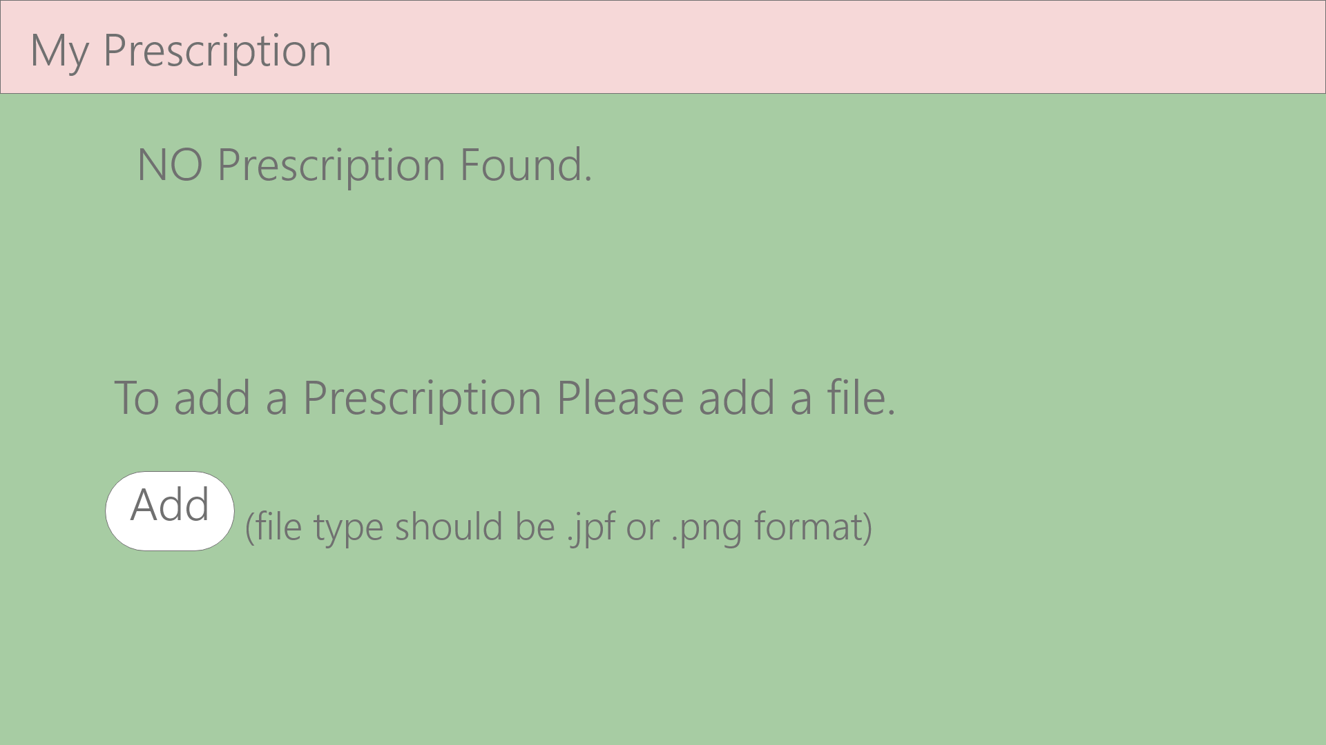

Here is the gui design for Blood bank

Here we will allow people to become a member

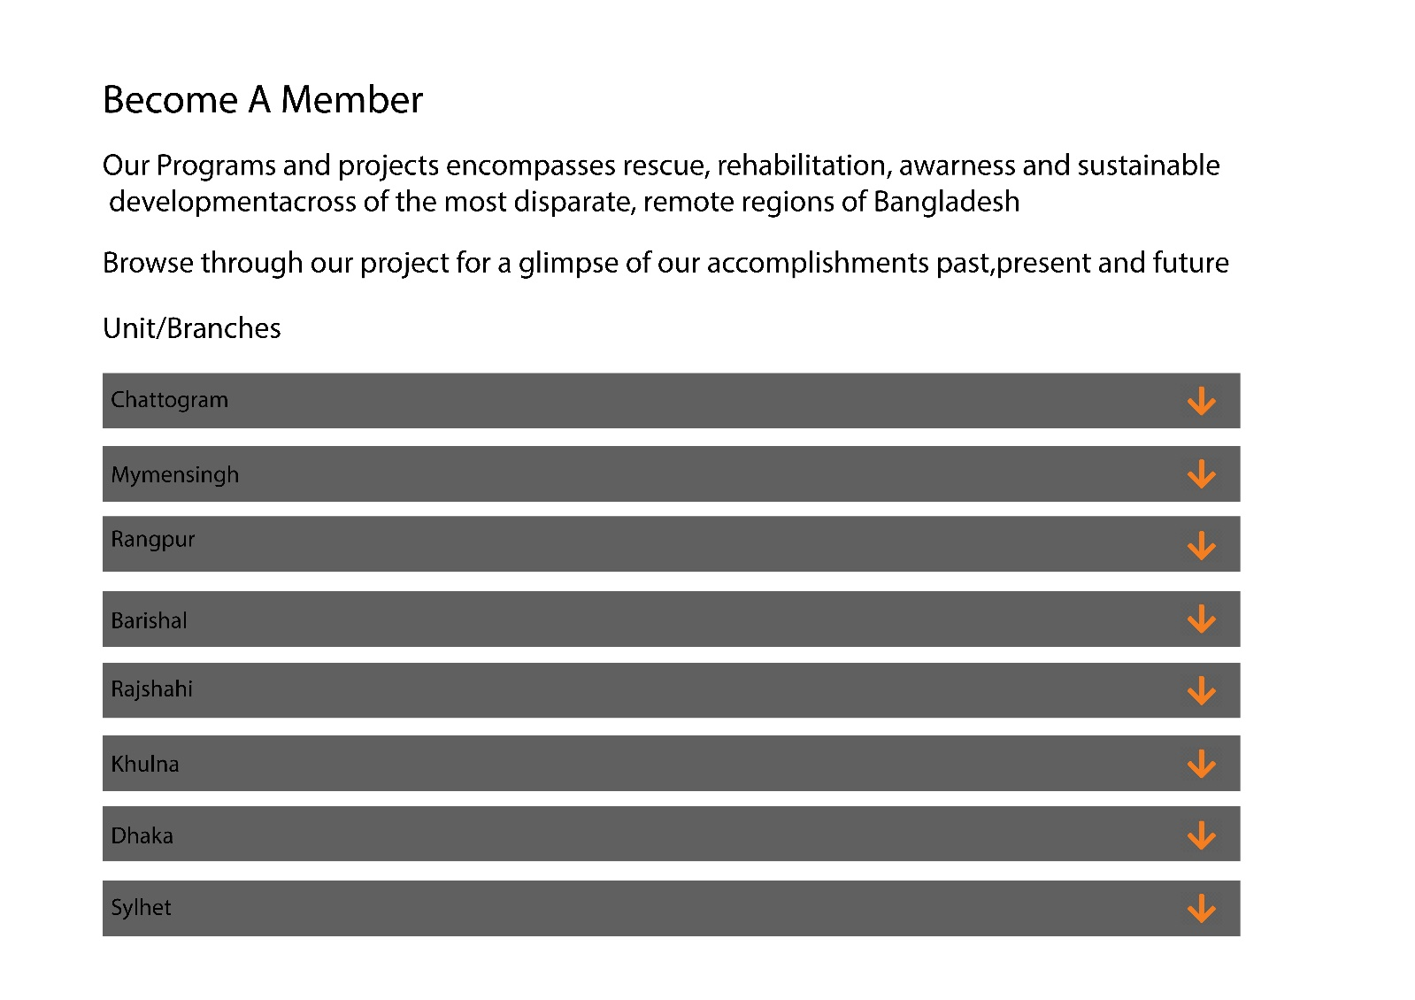

Here you can be a part of the organization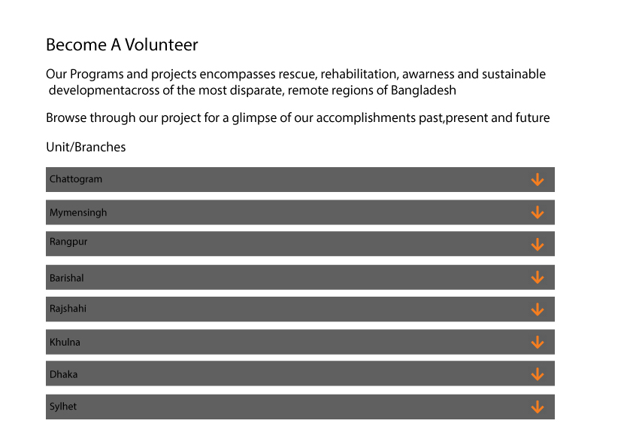

You can donate blood 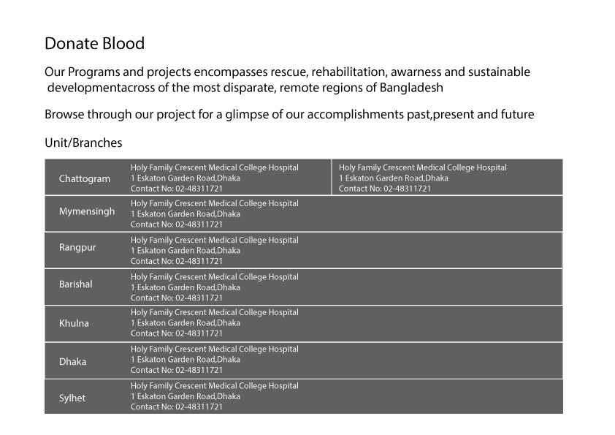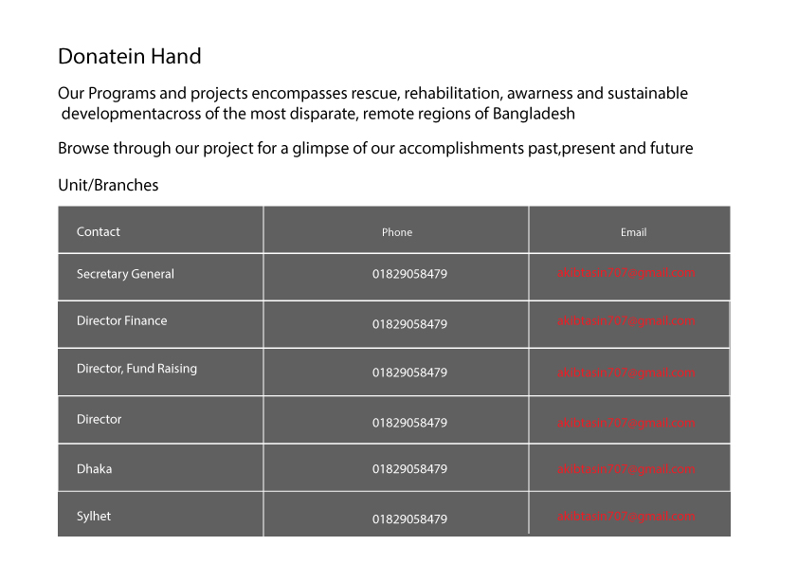

Here is the details for to become a donar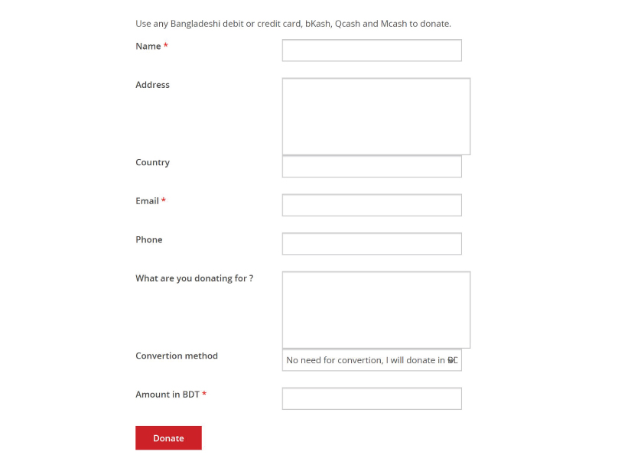

This will be the home page for blood banks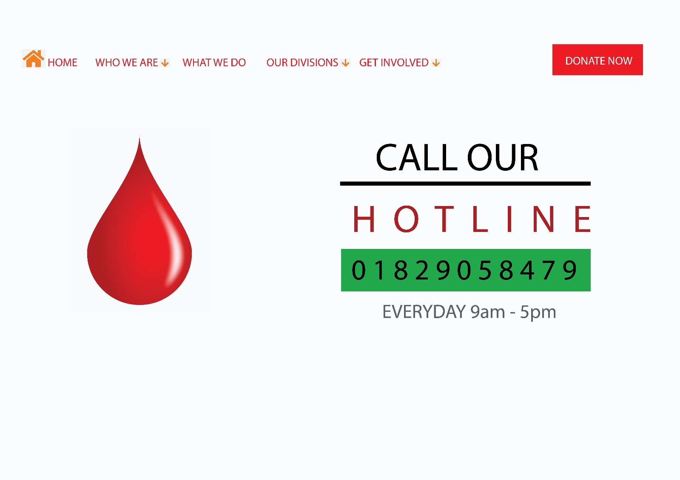

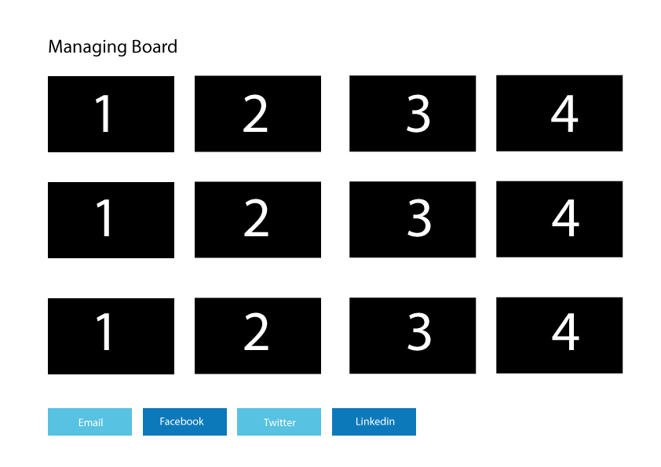

Here is our future goals of aor vission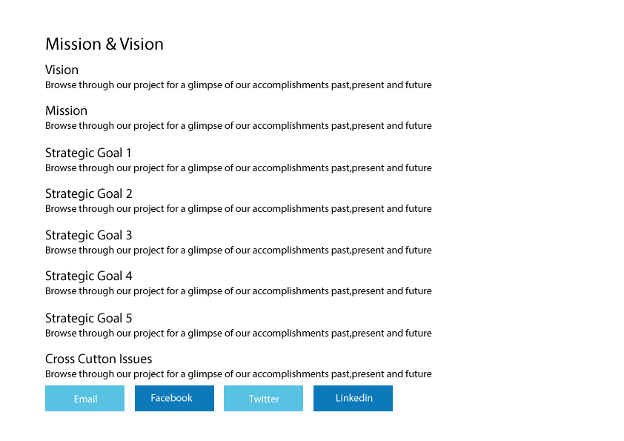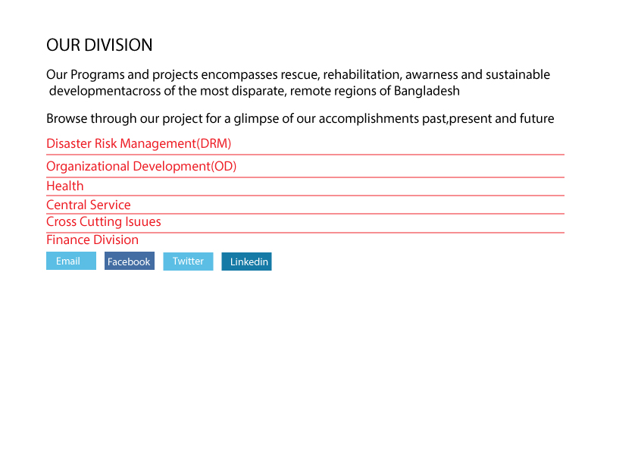

Here is the photo Gallery of our activities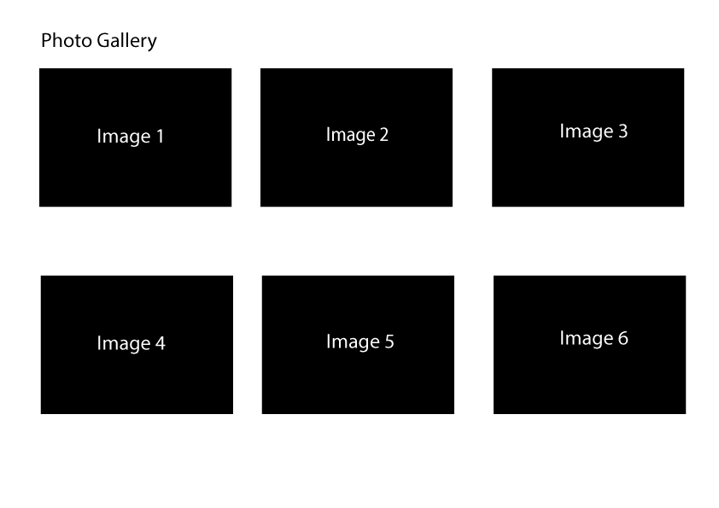

**Impact of this Project:**

Describe the increasing importance of your project on modern society and environment.

How will people be benefitted from your project?

(Maximum 80 words)

**Limitations and Possible Future Improvements:**

(Maximum 80 words)

|  |  |  |  |  |  |
| --- | --- | --- | --- | --- | --- |
| **CO1 and CO3 Evaluation: Project Report Evaluation** | | | | | |
| **Project Proposal**  **(5)** | **Background**  **Study**  **(5)** | **Requirement Analysis**  **(5)** | **Entity**  **Diagram**  **(5)** | **System Images**  **against the**  **Specification (5)** | **Total (25)** |
|  |  |  |  |  |  |
|  | | | | | |